ASSIGNMENT NO.11
TITLE: Implement Map reduces operation with suitable example using MongoDB.

PROBLEM STATEMENT: Implement Map reduces operation with suitable example using MongoDB.
OBJECTIVES:
- To understand Map reduces operation
- Use Mongodb to implement the Map reduce techniques

OUTCOMES:
- Students will apply the concepts of Map reduce.
- Students will be able to write queries for given requirements using Mongodb.

SOFTWARE & HARDWARE REQUIREMENTS:
- 64-bit Open source Linux or its derivative
- MongoDB Server

THEORY:

In MongoDB, map-reduce is a data processing programming model that helps to perform operations on large data sets and produce aggregated results. MongoDB provides the mapReduce() function to perform the map-reduce operations. This function has two main functions, i.e., map function and reduce function. The map function is used to group all the data based on the key-value and the reduce function is used to perform operations on the mapped data. So, the data is independently mapped and reduced in different spaces and then combined together in the function and the result will save to the specified new collection. This mapReduce() function generally operated on large data sets only. Using Map Reduce you can perform aggregation operations such as max, avg on the data using some key and it is similar to groupBy in SQL. It performs on data independently and parallel. Let’s try to understand the mapReduce() using the following example:

{"id":1, "sec":A, "marks":80}
{"id":2, "sec":A, "marks":90}
{"id":1, "sec":B, "marks":99}
{"id":1, "sec":B, "marks":95}
{"id":1, "sec":C, "marks":90}
Here we need to find the maximum marks in each section.
Inside the map function, we use emit(this.sec, this.marks) function, and we will return the sec and marks of each record(document) from the emit function. This is similar to group By MySQL.
var map = function(){emit(this.sec, this.marks)};
After iterating over each document Emit function will give back the data like this:
{“A”:[80, 90]}, {“B”:[99, 90]}, {“C”:[90] }
and upto this point it is what map() function does. The data given by emit function is grouped by sec key, Now this data will be input to our reduce function. Reduce function is where actual aggregation of data takes place. In our example we will pick the Max of each section like for sec A:[80, 90] = 90 (Max) B:[99, 90] = 99 (max) , C:[90] = 90(max).
var reduce = function(sec,marks){return Array.max(marks);};
Here in reduce() function, we have reduced the records now we will output them into a new collection.{out :”collectionName”}
db.collectionName.mapReduce(map,reduce,{out :"collectionName"});
In the above query we have already defined the map, reduce. Then for checking we need to look into the newly created collection we can use the query db.collectionName.find() we get:

{"id":"A", value:90}
{"id":"B", value:99}
{"id":"C", value:90}

Syntax:
db.collectionName.mapReduce(
... map(),
...reduce(),
...query{},
...output{}
);

Here,
- map() function: It uses emit() function in which it takes two parameters key and value key. Here the key is on which we make groups like groups by in MySQL. Example like group by ages or names and the second parameter is on which aggregation is performed like avg(), sum() is calculated on.
- reduce() function: It is the step in which we perform our aggregate function like avg(), sum().
- query: Here we will pass the query to filter the resultset.
- output: In this, we will specify the collection name where the result will be stored.

CONCLUSION:

QUESTIONS:
Consider the Example:
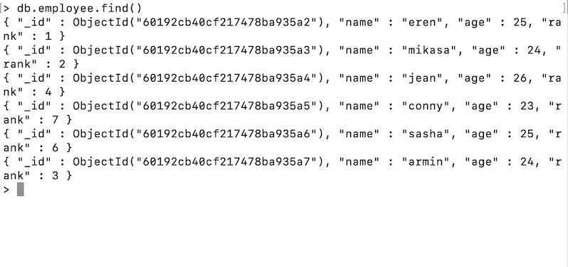
Find the sum of ranks grouped by ages with the use of Map reduces techniques using Mongodb

